Completed Registration
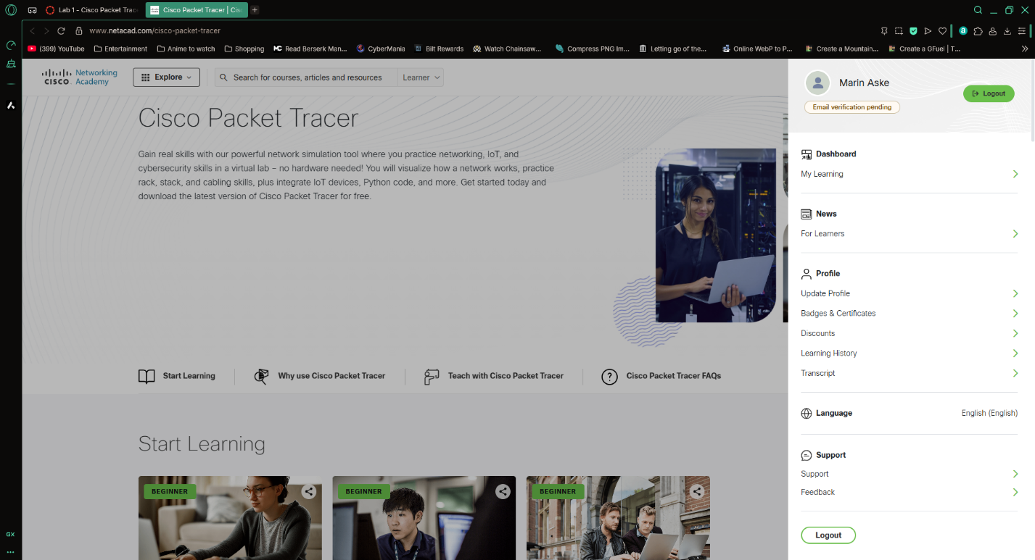
Getting Started Exam Results
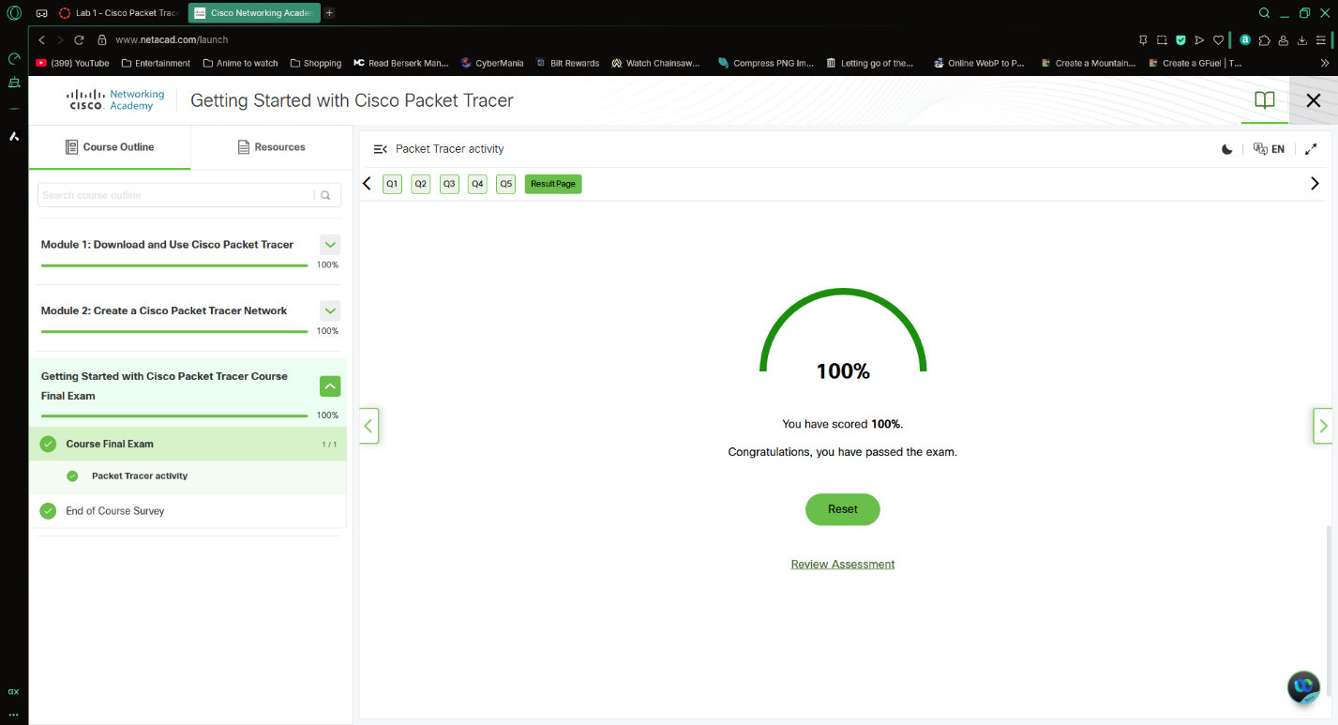

Exploring Networking with Cisco Packet Tracer Exam Results
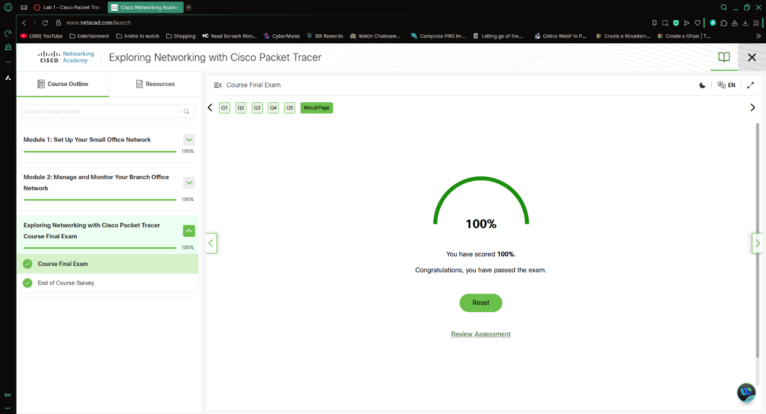
Exploring Internet of Things with Cisco Packet Tracer
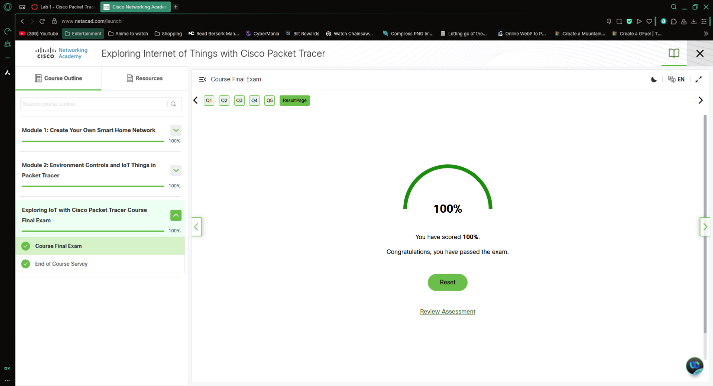

Completion Badges of All 3 Sections
